Chapter 10, Problem 70.

Using Fig. 10.113, design a problem to help other students better understand op amps in AC circuits.
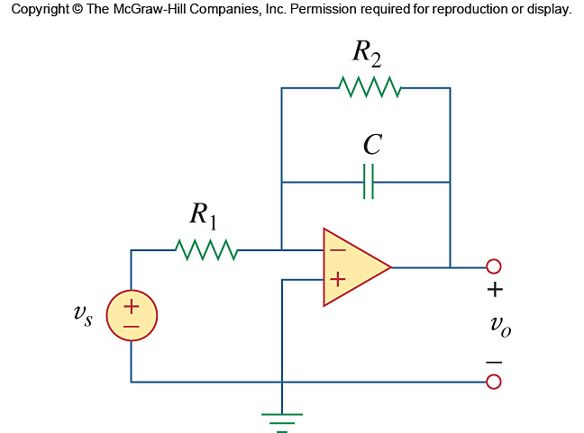

Figure 10.113
For Prob. 10.70.

